**Additional features of Oxygen XML editor**

1. **Tracking changes in DITA topics** 

* When you add any content in existing topics , to track that changes we can use this feature
* Select options 🡪 preference 🡪 enable tracking of deletion and insertion

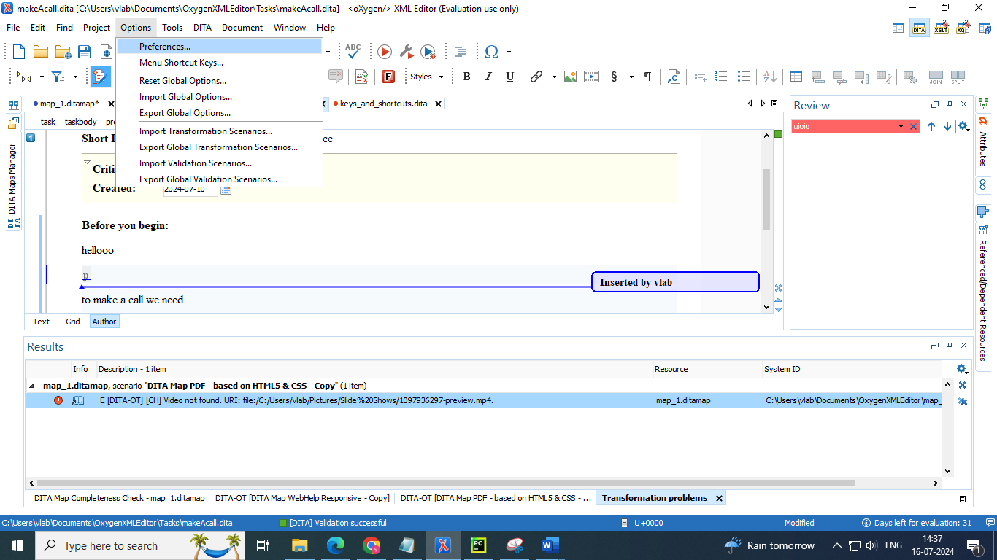

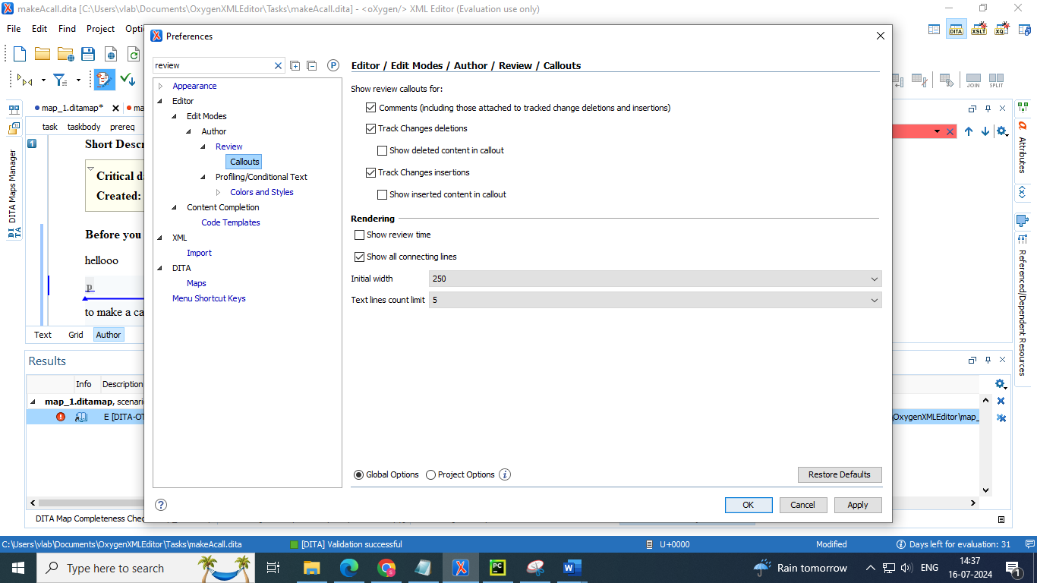

* Select window 🡪 show view 🡪 more 🡪 review : to view the changes we have made in the topics

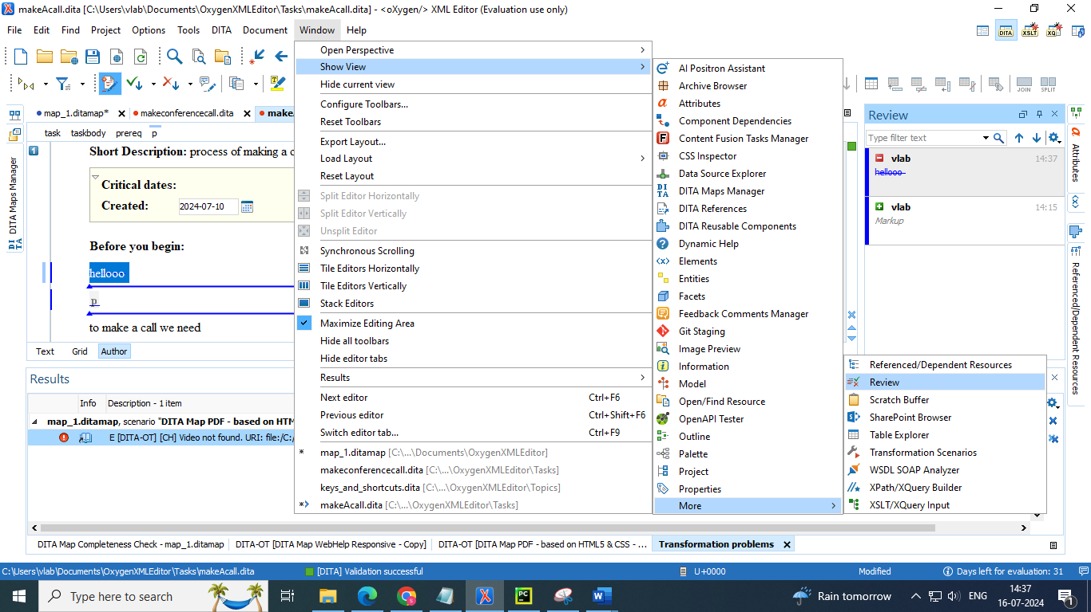

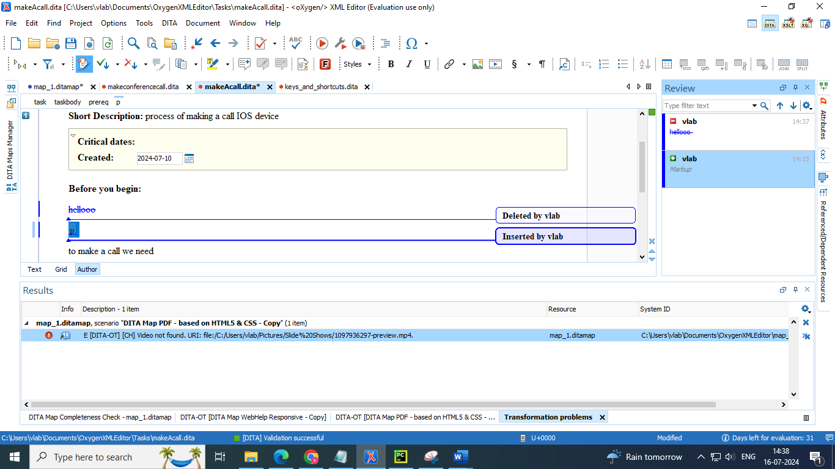

1. **Adding comments** 

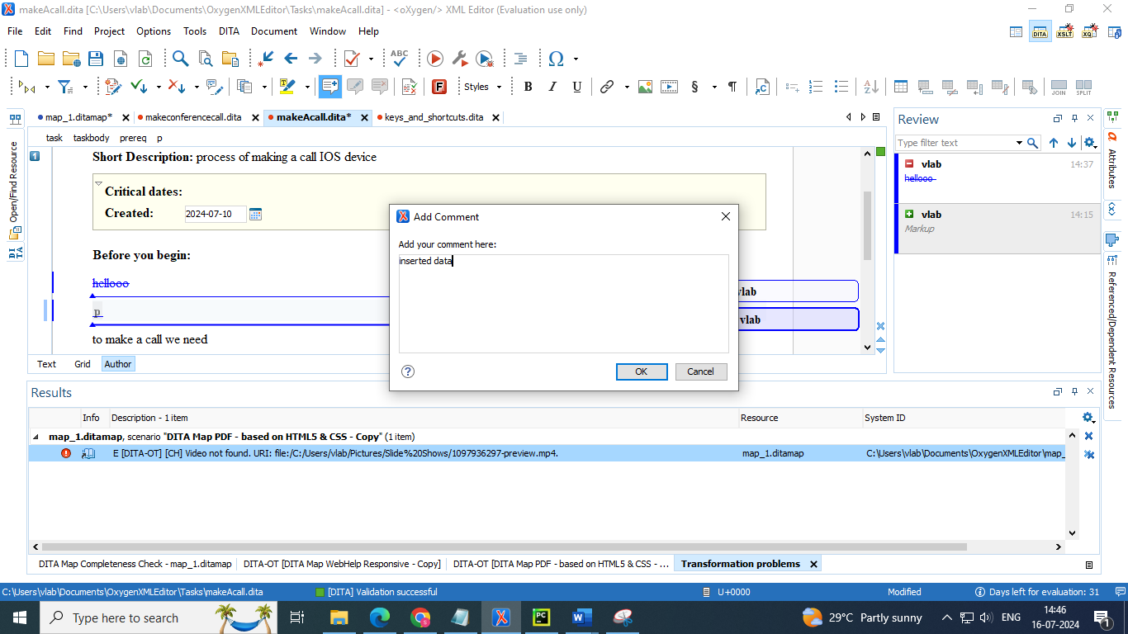

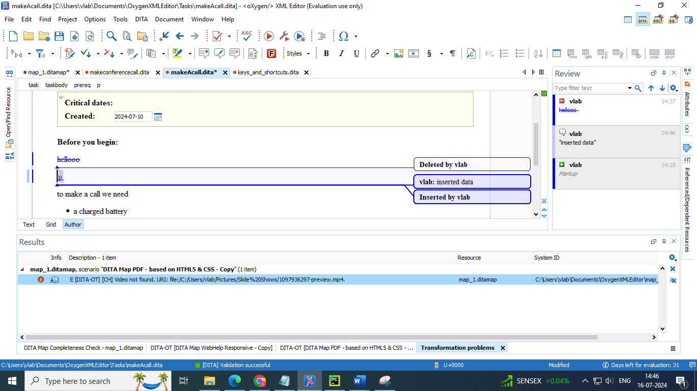

1. **Viewing tags added** 

